Telus house atrium
Student’s name
Institutional affiliation
Course
Instructor’s name
Date

Telus house atrium

Green building is the structure and the application of process that are environment friendly and resource efficient during the entire building process or cycle starting from the plan to design, construction, operations, maintenance renovation till demolition.
A good example of this green building is the TELUS house atrium (CLDN Arch Jan /08). This is the tallest building in Canada west of Toronto at the time when its completion ended and it was opened on 15th July 1975 where a capsule of dimension 25*5*20 was cemented into the building to remain on it provided the building was in existence. The green building is found in the state of Alberta city of Edmonton with main address as 10020100 street NW and address text 1002-100 street NW. The initial design of the of the building was vertical without horizontal outward components. It was used as viewing deck up to the time when corporate decided to convert the space for official usages.
The authorized certification included the following measurements and requirements,
Height (tip) and height (architectural) of 134.40m
Floor (above the ground) of 34
Floor (below the ground) of 3
Construction start year 1969
Construction end year 1971
Elevators 19
Building costs $22,000,000
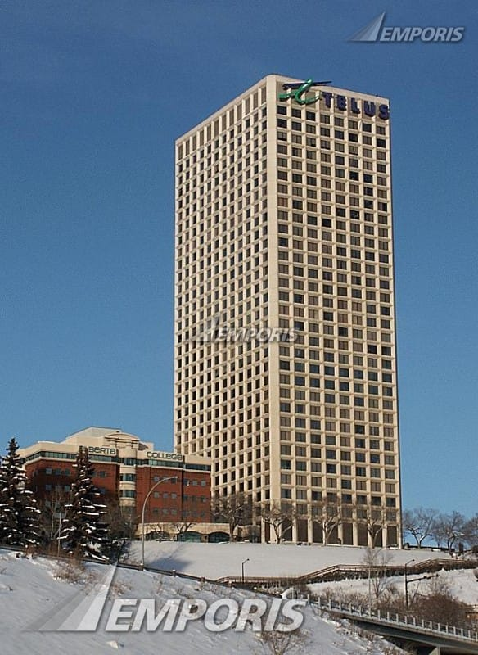
Telus house atrium
Sustainable design features or architecture is the strategy of building with the aim of reducing harmful impact on the environment and this should be the aspect of every building process. These sustainable building designs may include,
K2 APARTMENTS

This is most sustainable public housing strategy in Australia. This apartment is estimated to have a lifespan of not less than 200 years and it only consumes renewable sources of energy.
This architecture design is characterized by the following features,
Rainwater harvesting
Recycled timber
Sun water heating
Photovoltaic panels

Reports originating from Victorian housing Government depicts that K2 apartments consumes 46% lessgas, 55% electricity, and 53% of less water as compared to conventional apartments.
CENTRE FOR SUSTAINABLE DEVELOPMENT

This architecture design was situated in Montreal, Canada.it was purposely constructed to function as a model for environmentally friend construction. Where many people refer to it as greenest construction in Canada. The design includes the following characteristics;
five-storeyed wall acting as natural air filter
Raising floor heating
Geothermal cooling and heating machines.
Recycled glasses which makes the countertops
This sustainable design displays artwork made up of 100% organic materials.

LTL architects (Lewis .Tsurumaki.Lewis) it was an architectural designed firm which was initiated by Paul Lewis, Marc Tsurumaki and David Lewis in 1997, which was allocated In New York city. It performs large scale academic and cultural buildings to speculative research projects and arrives to optimum solutions. It has also accomplished academic, institutional and hospitality projects in United States. Some of the firms buildings are, 23800SF renovation of the contemporary AUSTIN –JONES Centre, accomplished the 160,000SF transformation of Upson hall at Cornell University among others

Additional examples of buildings and their photographs.
K2 apartment

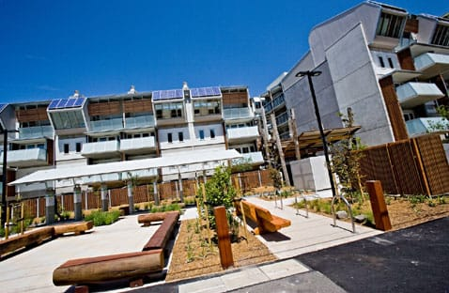
Center for sustainable development house
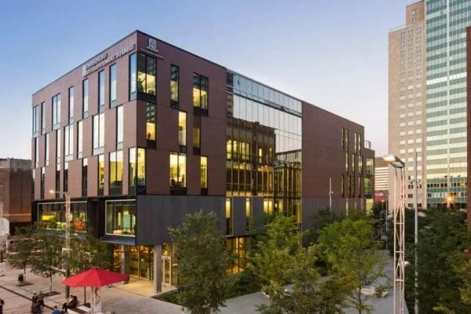

References:
Mao, Huimin, Li (2009). “A comparison Study of Green Building Rating Tools in the World”.
Global Alliance for Building and Construction; International Energy Agency; United Nations International Programs (2019).
Allen and Lano.(2008). Fundamentals of Building and Construction: materials and methods.

